

To: All Bidders | Date: 3/6/2026
Quote #: 26-#####
Reference: ########
MEP Engineer: #######
Based on Plans and Specs:
########

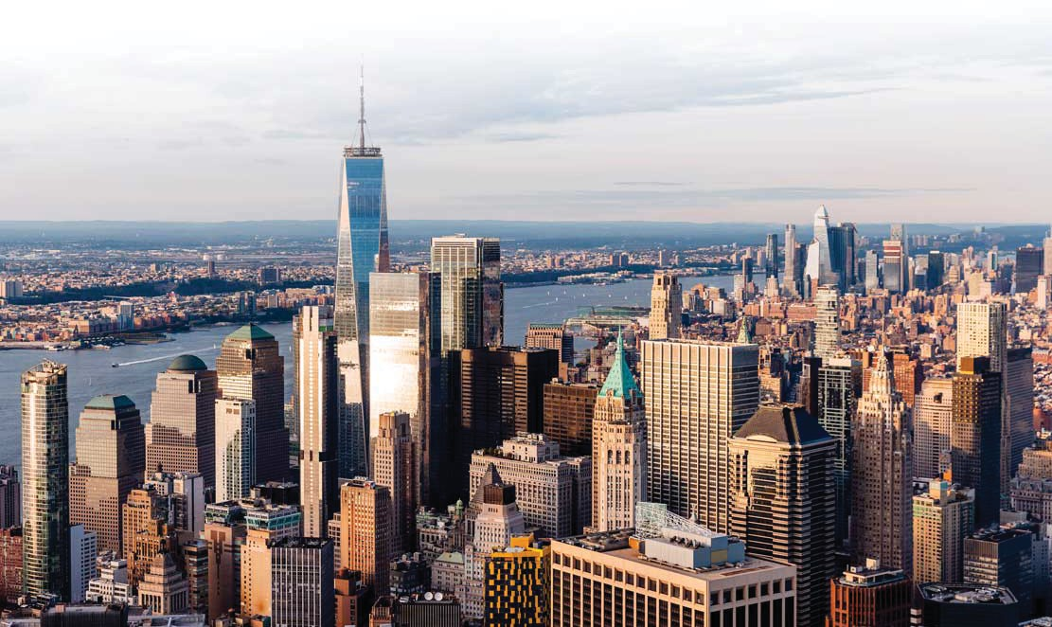




Scope and Quotation

A.M.E., Inc, is pleased to provide a quotation on the above project to provide Automated Temperature Controls system.

SCOPE OF WORK –
- Front End Web Enabled BMS System
  - Furnish Network Level Control Panel
  - Furnish PC Workstation
  - Furnish BMS Server
  - Furnish POT (Laptop or Tablet)
  - Furnish UPS
  - Furnish 3-D Graphics
  - Furnish Necessary Training on New Controls
  - IT Infrastructure – By AME or by Others?
    - Network Switches
    - Panels
    - Fiber – Ethernet

OR

A.M.E., Inc, is pleased to provide a quotation on the above project to provide an extension of the existing District Wide BMS system.

SCOPE OF WORK –
- Seamlessly Tie in to the Existing Honeywell / Niagara N4 BMS
  - Furnish Network Level Control Panel
  - Furnish 3-D Graphics to match existing
  - Furnish Necessary Training on New Controls

ADD ALTERNATES:

- ALT #:

DEDUCT ALTERNATES:

- ALT #:

        - Clarifications and Inclusions considered:
          - All labor will be performed during normal business working hours (M to F, 7AM to 4PM).
          - All Motor starters require Hand-Off-Auto switches, control transformers and coils.
          - All Motor starters and/or variable frequency drive are to be located within the vicinity of the associated controlled equipment.
          - The Division 23 BMS electrical work shall be performed in accordance with the following installation practices:
            - All new wiring in exposed or wiring in machine equipment rooms shall be in EMT conduit.
            - All new wiring in exterior areas, or where exposed to the elements shall be installed with galvanized EMT or RGS conduit with appropriate fittings.
            - All unexposed low voltage wiring outside of the mechanical equipment rooms, where applicable, can be in plenum rated cable.
            - The fire stopping of the new BMS control wiring is included.
            - The Division 26 EC shall deliver a designated power source to within 5 feet of BMS control panels.
        - Exceptions and Exclusions: The following items, unless specifically mentioned in the “Scope of Work and Equipment included” or the “Clarifications” sections of this document are excluded from this quotation.
          - All off-hours or overtime labor.
          - All temporary heating or cooling.
          - All equipment manufacturer integration/communication devices, setup and/or programming.
          - All equipment manufacturer wall sensor guards, if required.
          - The integration and communications into competitive building management systems.
          - The cost of material & setup of the third party communication devices.
          - All water flow and/or air flow balancing and calibration.
          - The installation of dampers, valves, wells, water flow meters and/or air flow stations.
          - The installation of control valves, piping taps and thread-o-lets.
          - All power wiring of mechanical equipment (RTU, VFD, Pumps, Boiler, UH, UV, FCU, etc.).
          - EMT or RGS conduit (if specified) other than exterior areas and mechanical equipment rooms.
          - Any computers and/or related equipment, including but not limited to, routers, monitors, printers, etc.
          - All mechanical equipment (i.e. AHU, VAV, Pumps, VFDs, etc.).
          - All air flow monitoring station.
          - All water flow meters.
          - All electric power meters.
          - All gas meters.
          - All motor starters.
          - All variable frequency drives.
          - Any equipment housekeeping pads
          - The Boiler Control Panel and associated control devices.
          - Any gas detection system or components.
          - Any demolition work not mentioned.
          - All fire alarm system or components, smoke, combination fire/smoke dampers, smoke detectors and associated wiring.
          - Installation and maintenance of any high-speed internet connections.
          - All control dampers.
          - Any site excavation and/or trenching.
          - All cutting, patching, and/or painting.
          - Any core drilling of floors, walls and/or partitions.
          - Any roof penetrations, pitch pockets required.
          - Any costs associated for factory-mounting and wiring of AME provided devices.
          - All site cleanup back-up charges not produced by the work under this Scope of Work.
          - Any checkout, repair, replacement, or warranty of existing controlled equipment.
          - Any bid, performance, maintenance, or payment bonds.
          - Any Taxes and/or Permit Fees (on applicable jobs)
          - All project allowances
          - Any demolition work not specifically mentioned
Base Price: ……………………$
This price is valid for 30 days from the quoted date
Pricing is subject to change based on tariffs

ADD ALTERNATE:
- ALT # - ……………………$
DEDUCT ALTERNATE:
- ALT # - ……………………$
Thank you for the opportunity to quote this job. Should you have any questions, please feel free to call me direct.
Respectfully,

Eric Niedle

Eric Niedle

A.M.E., Inc.

Connected Buildings Made Smarter



Corporate Headquarters
695 US-46 Suite 403, Fairfield, NJ 07004

AME New York
Long Island City, NY 11101
GENERAL CONTACT
973-884-4100
info@ame-inc.com
www.ame-inc.com
AME Pennsylvania
Newtown, PA 18940
SERVICE AND SUPPORT

973-884-4100
service@ame-inc.com

Support Hours: 24/7/365
AME Texas
Dallas, TX

